POST 1
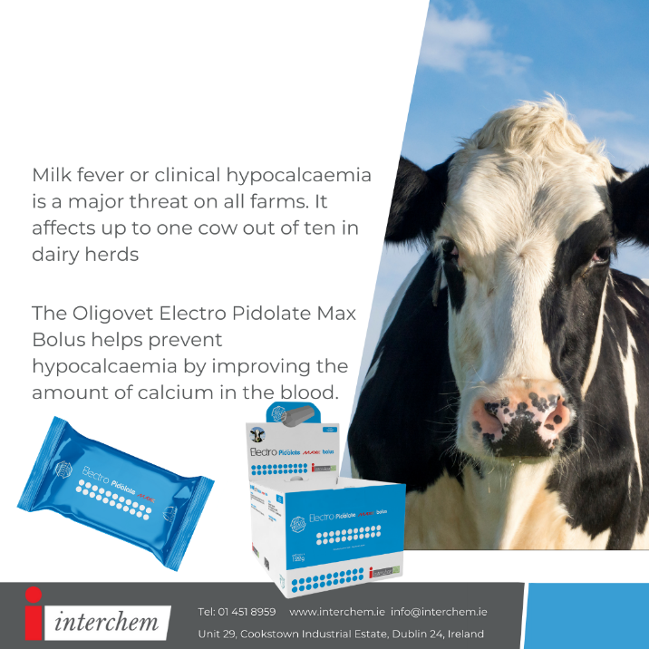
With calving season in full swing, milk fever is a major threat on farms. The Oligovet Electro Pidolate Max Bolus provides 40 hours of controlled release of calcium to help prevent milk fever.
Talk to us today about the Electro Pidolate Max Bolus.
#teamdairy #milkfever #calvingseason #calving2022 #calf #cow #cows #farm #cattle #farmlife #calves #farming #milk #farmanimals #dairy #farmer #heifer #agriculture #happycow #irishfarming #grasstomilk #calving #spring2022 #dairyfarming #beeffarming #animalhealth #calvingseason2022

POST 2
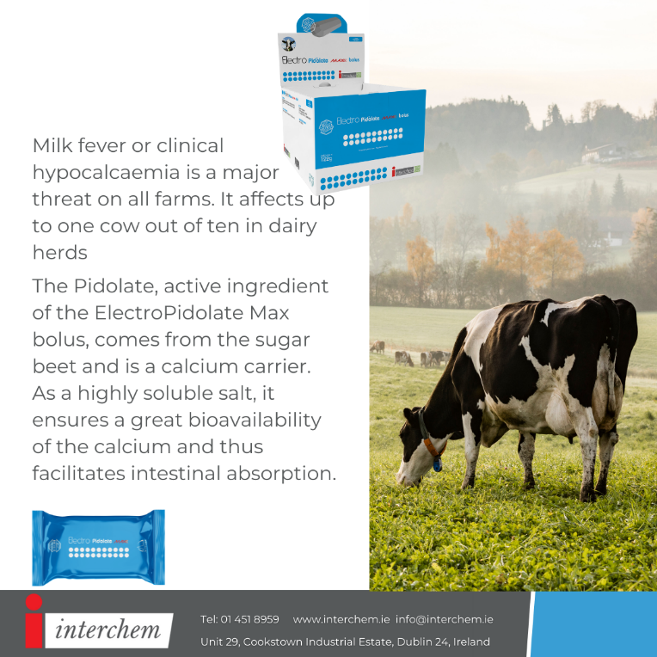
Calcium (Ca) plays a huge role in muscle function and immunity. Milk fever occurs when blood Ca levels drop too low to support the functions of the nerve cells and the contractions of muscle tissue. Supplement your cows at the first sign of calving with the Electro Pidolate Max Bolus.
Talk to us today about the Electro Pidolate Max Bolus.
#teamdairy #milkfever #calvingseason #calving2022 #calf #cow #cows #farm #cattle #farmlife #calves #farming #milk #farmanimals #dairy #farmer #heifer #agriculture #happycow #irishfarming #grasstomilk #calving #spring2022 #dairyfarming #beeffarming #animalhealth #calvingseason2022

POST 3
Milk fever is a huge threat on farms. Clinical cases of milk fever are merely the tip of the iceberg. For every clinical case on a farm, there can be up to 10 sub-clinical cases that are undiagnosed.
Talk to us today about the Electro Pidolate Max Bolus.
#teamdairy #milkfever #calvingseason #calving2022 #calf #cow #cows #farm #cattle #farmlife #calves #farming #milk #farmanimals #dairy #farmer #heifer #agriculture #happycow #irishfarming #grasstomilk #calving #spring2022 #dairyfarming #beeffarming #animalhealth #calvingseason2022

POST 4
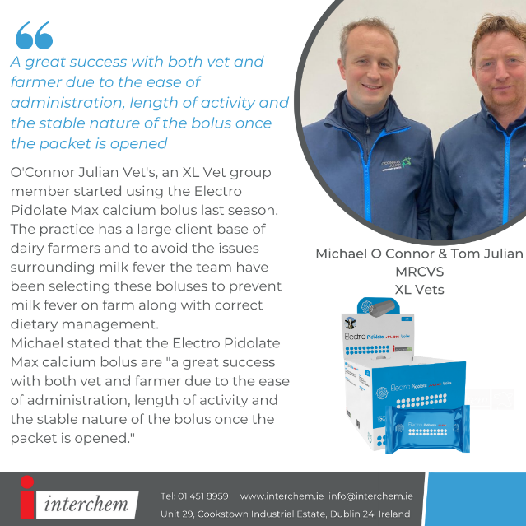

Check out Michael O’Connor and Tom Julian’s testimonial on the Oligovet Electro Pidolate Max calcium bolus. Michael and Tom are from O’Connor Julian Veterinary Hospital in Cashel, Co. Tipperary.
Talk to us today about the Electro Pidolate Max Bolus.
#teamdairy #milkfever #calvingseason #calving2022 #calf #cow #cows #farm #cattle #farmlife #calves #farming #milk #farmanimals #dairy #farmer #heifer #agriculture #happycow #irishfarming #grasstomilk #calving #spring2022 #dairyfarming #beeffarming #animalhealth #calvingseason2022

POST 6
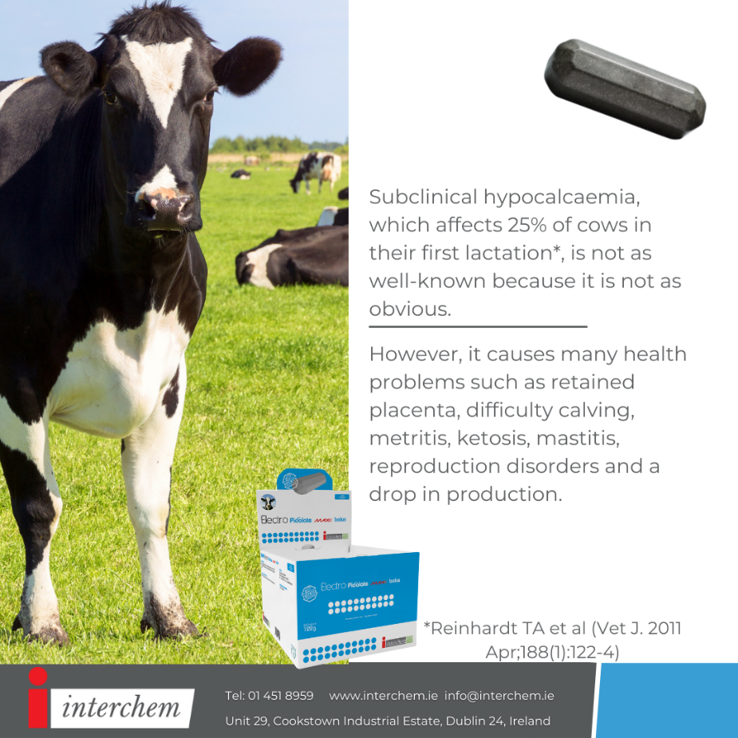
When it comes to milk fever prevention is better than cure! Subclinical milk fever can cause many health problems such as, retained placenta, difficulty calving, metritis, kerosine, mastitis, reproduction disorders and a drop in production
Talk to us today about the Electro Pidolate Max Bolus.
#teamdairy #milkfever #calvingseason #calving2022 #calf #cow #cows #farm #cattle #farmlife #calves #farming #milk #farmanimals #dairy #farmer #heifer #agriculture #happycow #irishfarming #grasstomilk #calving #spring2022 #dairyfarming #beeffarming #animalhealth #calvingseason2022

POST 7
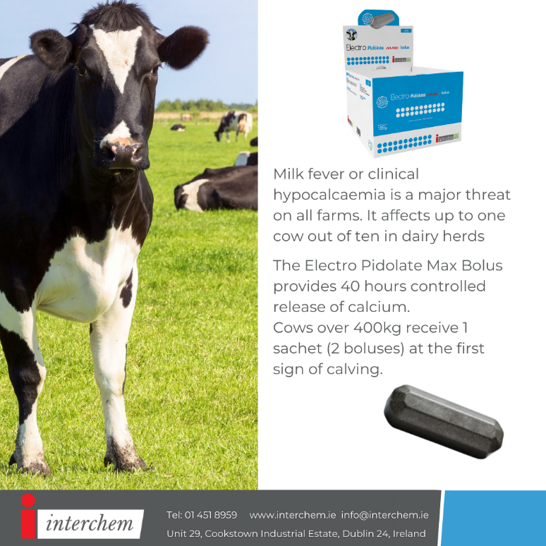
Invest in your herd to prevent clinical and subclinical milk fever this season with Electropidolate at calving: the only 40-hr calcium and magnesium bolus to cover cows through their entire high-risk period.
Talk to us today about the Electro Pidolate Max Bolus.
#teamdairy #milkfever #calvingseason #calving2022 #calf #cow #cows #farm #cattle #farmlife #calves #farming #milk #farmanimals #dairy #farmer #heifer #agriculture #happycow #irishfarming #grasstomilk #calving #spring2022 #dairyfarming #beeffarming #animalhealth #calvingseason2022

