POST 1

Eprecis is the only injectable eprinomectin on the Irish market with ZERO milk withhold. It is effective against major gut parasites and lungworm #TakeBackControl #Eprecis

POST 2

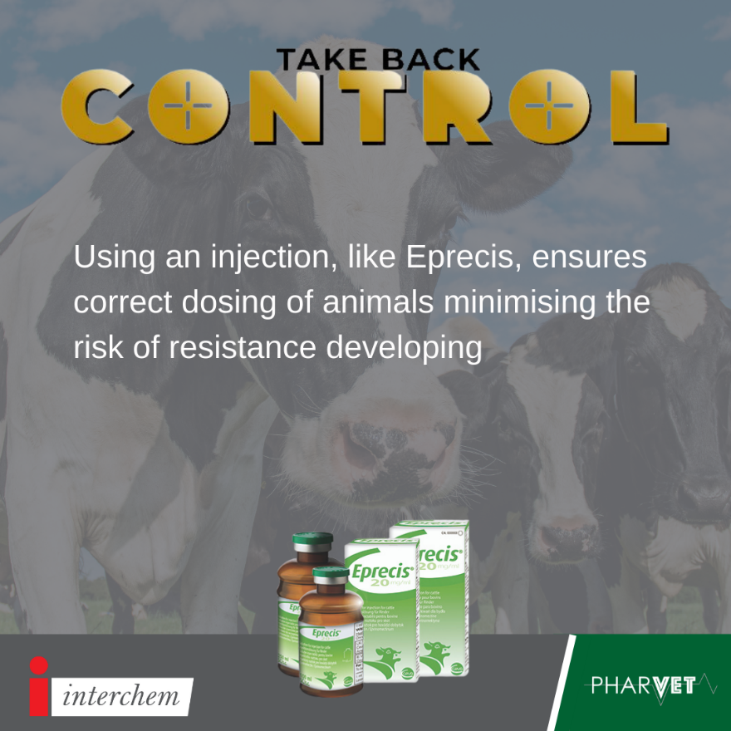
Eprecis is the only injectable eprinomectin on the Irish market with ZERO milk withhold. It is effective against major gut parasites and lungworm #TakeBackControl #Eprecis

POST 3

Studies show that cattle that had not been treated with a pour-on still had concentrations of product in their system due to licking of treated animals. As Eprecis is an injection it will not be effected by grooming. Click the link in our bio to find out more on these studies. #TakeBackControl #Eprecis

POST 4

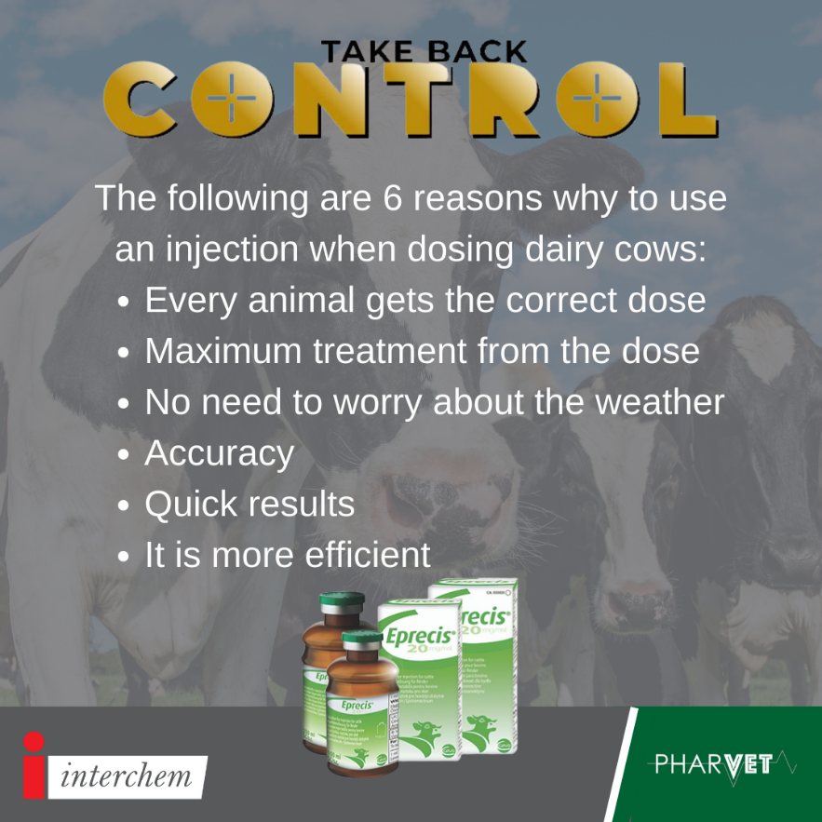

Eprecis is the only injectable eprinomectin on the Irish market with ZERO milk withhold. It is effective against major gut parasites and lungworm #TakeBackControl #Eprecis

POST 5

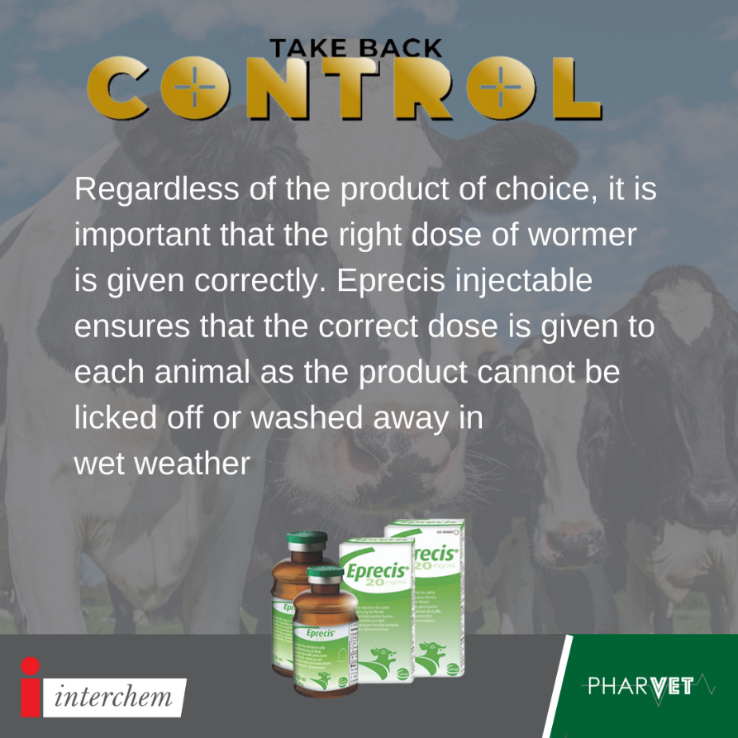

Anthelmintic resistance is the heritable (and therefore genetic) ability of the parasitic worms to survive treatment with an anthelmintic. Inaccurate dosing or sub-dosing is a leading cause of Anthelmintic resistance as it exposes parasites to sub-therapeutic amounts of the drug thus enabling them to develop resistance more readily to these lower doses. #takebackcontrol #eprecis

POST 6

Eprecis is the only injectable eprinomectin on the Irish market with ZERO milk withhold. It is effective against major gut parasites and lungworm #TakeBackControl #Eprecis

POST 7

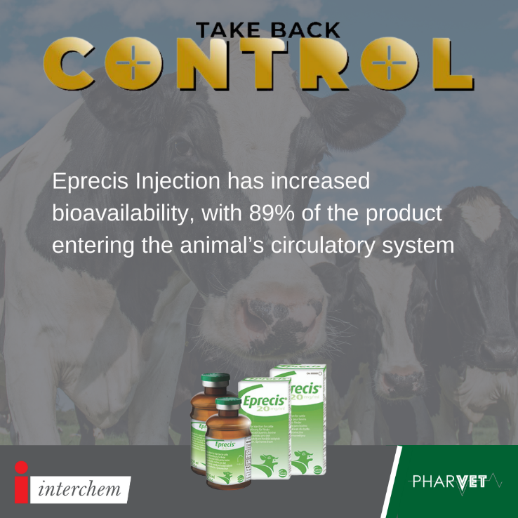
Eprecis is the only injectable eprinomectin on the Irish market with ZERO milk withhold. It is effective against major gut parasites and lungworm #TakeBackControl #Eprecis

POST 8

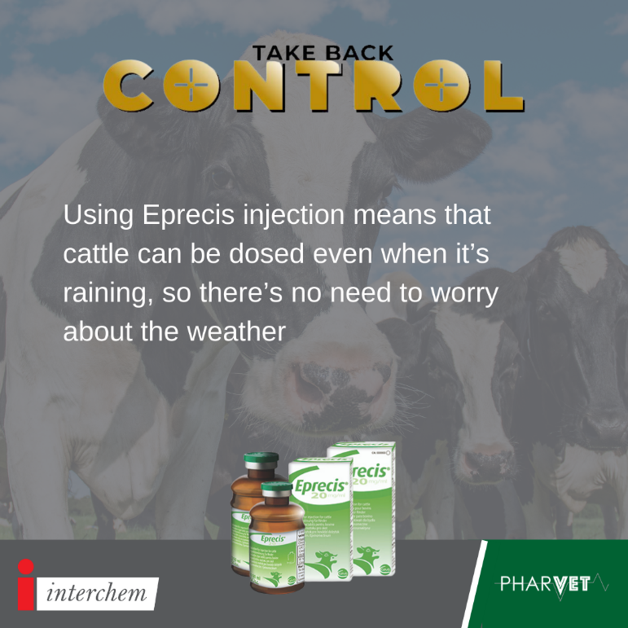

Eprecis is the only injectable eprinomectin on the Irish market with ZERO milk withhold. It is effective against major gut parasites and lungworm #TakeBackControl #Eprecis

POST 9

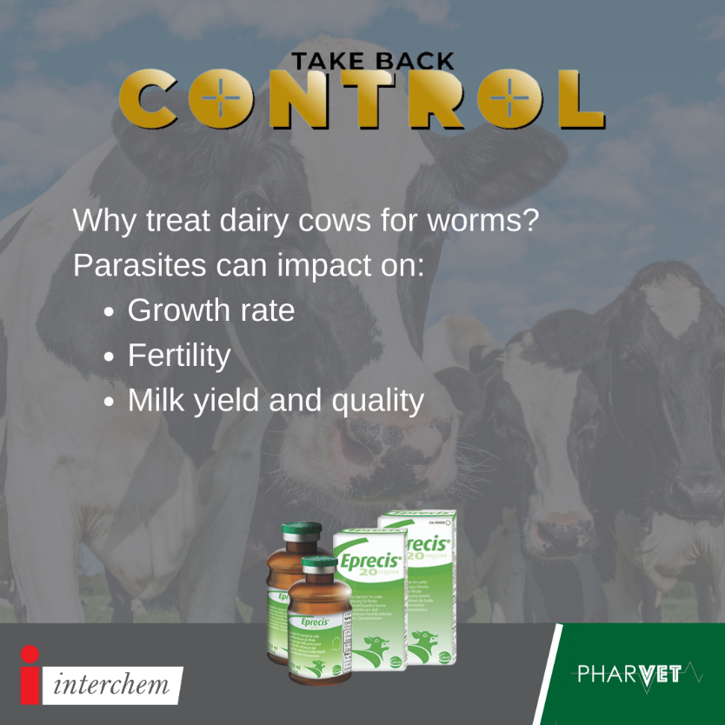

Eprecis injectable is the only injectable eprinomectin on the Irish market. Lungworm can have a significant economic impact with a total loss of €159-€167 per cow #Eprecis #TakeBackControl

POST 10

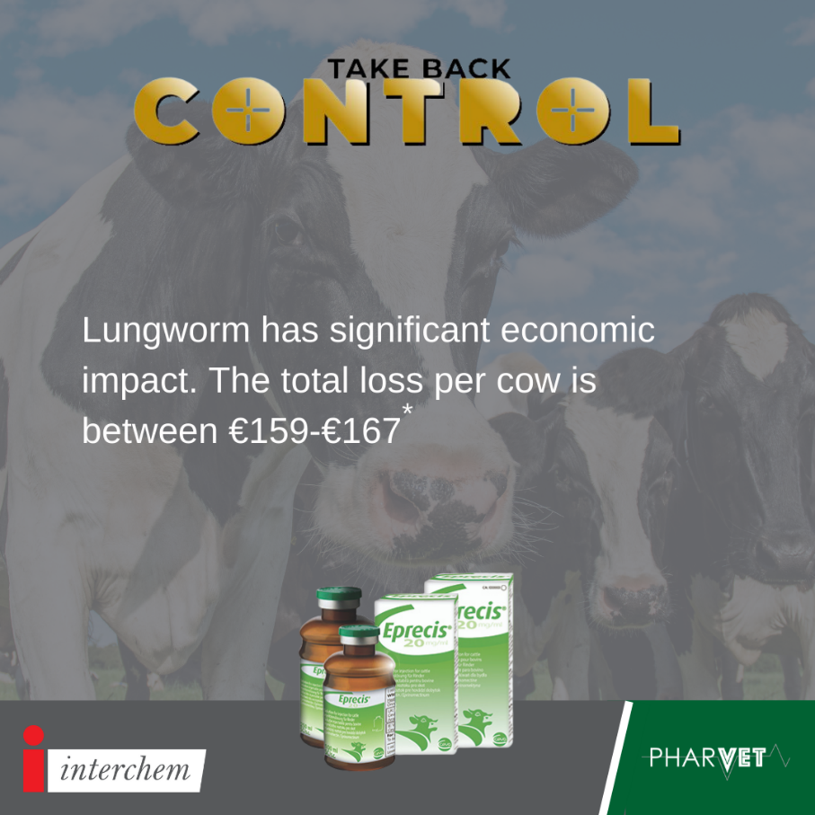

Eprecis injectable is the only injectable eprinomectin on the Irish market and is effective again lungworm. An outbreak of lungworm can cause significant financial loss to a farm, up to €159-€167 per cow, through reduced milk yield, mortality, reduced fertility and diagnostic and treatment costs (Holzhauer et al 2011) Animal health and welfare is a concern as lungworm can cause parasitic pneumonia and death. #TakeBackControl #Eprecis

POST 11

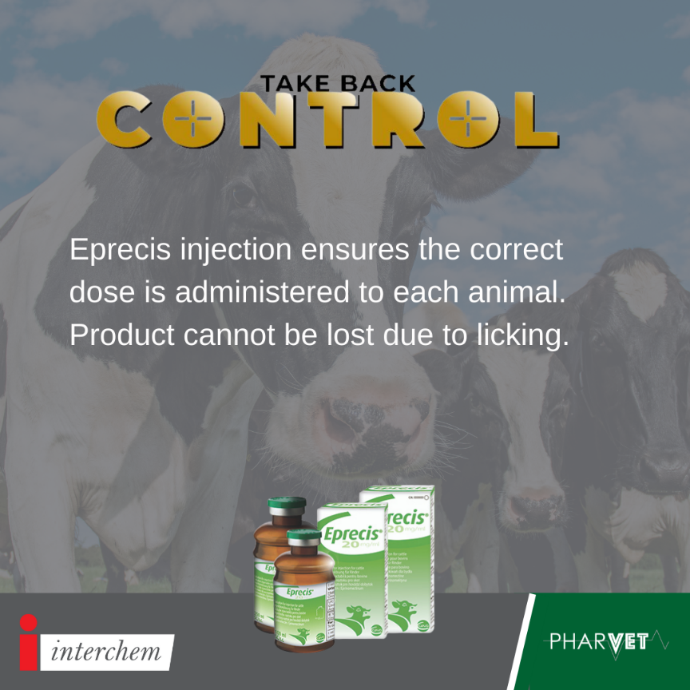
Studies show that cattle that had not been treated with a pour-on still had concentrations of product in their system due to licking of treated animals. As Eprecis is an injection it will not be effected by grooming. Click the link in our bio to find out more on these studies. #TakeBackControl #Eprecis

POST 12

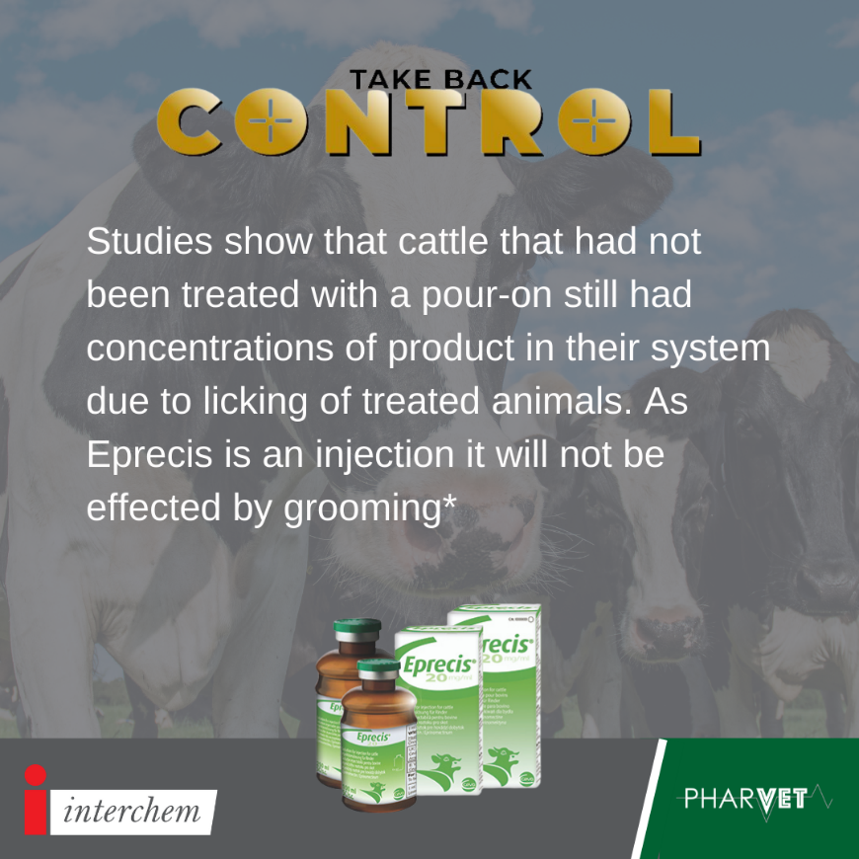

Eprecis is the only injectable eprinomectin on the Irish market and it is effective again lungworm and gutworm. Inaccurate dosing or sub-dosing is a leading cause of anthelmintic resistance as it exposes parasites to sub-therapeutic amounts of the drug. #takebackcontrol #eprecis

POST 13

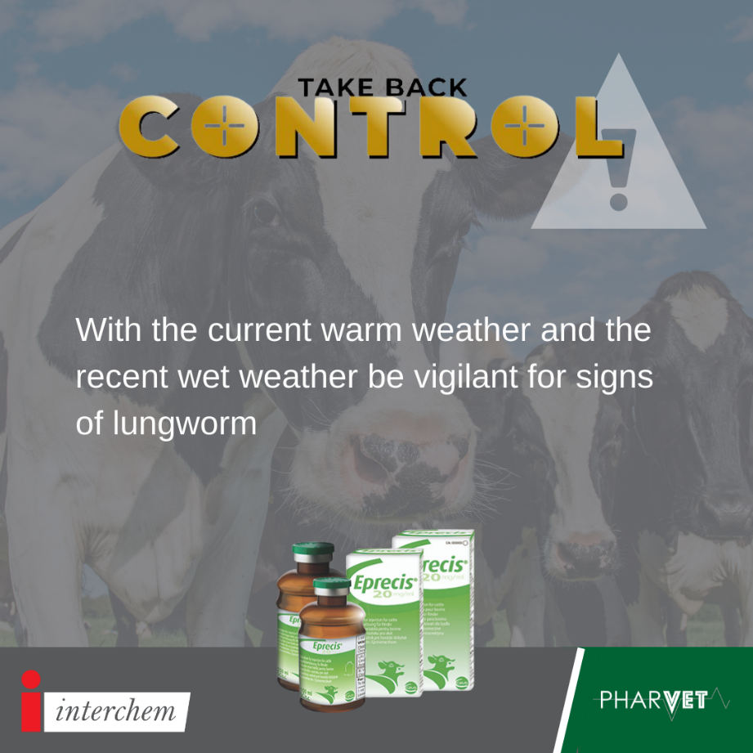

Keep an eye out for coughing cows❗❗ Current weather conditions are ideal for lungworm🌨⛅ Click the link in our bio to read our blog on the lifecycle of the lungworm #TakeBackControl #Eprecis

POST 14

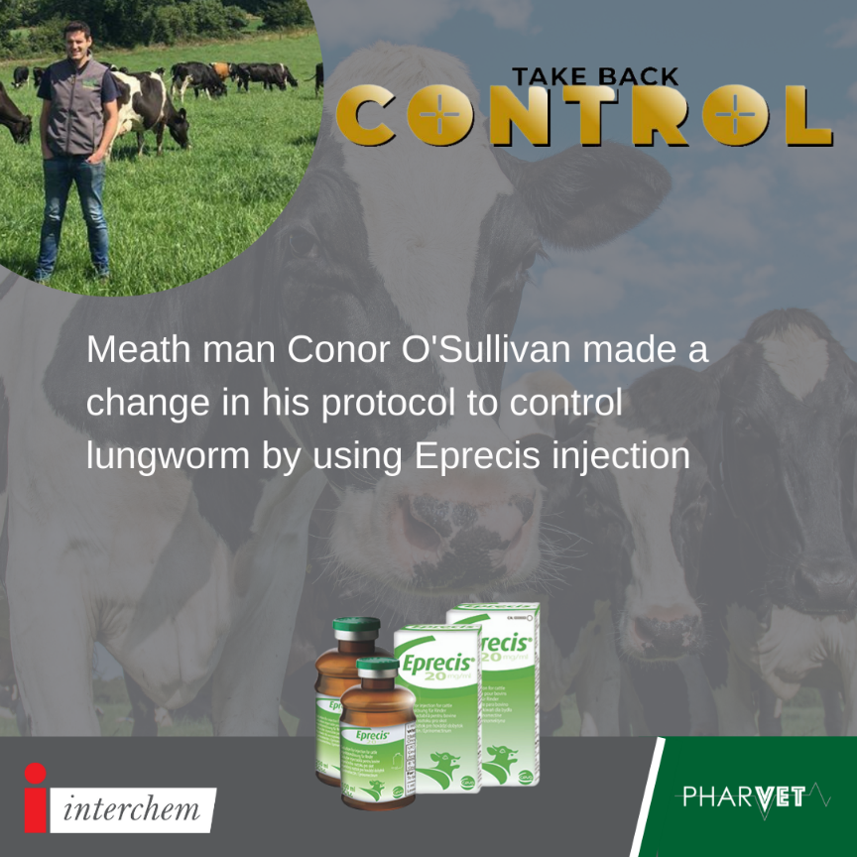

Conor uses Eprecis for a number of reasons. Click the link in our bio to find out more. #Eprecis #TakeBackControl

POST 15

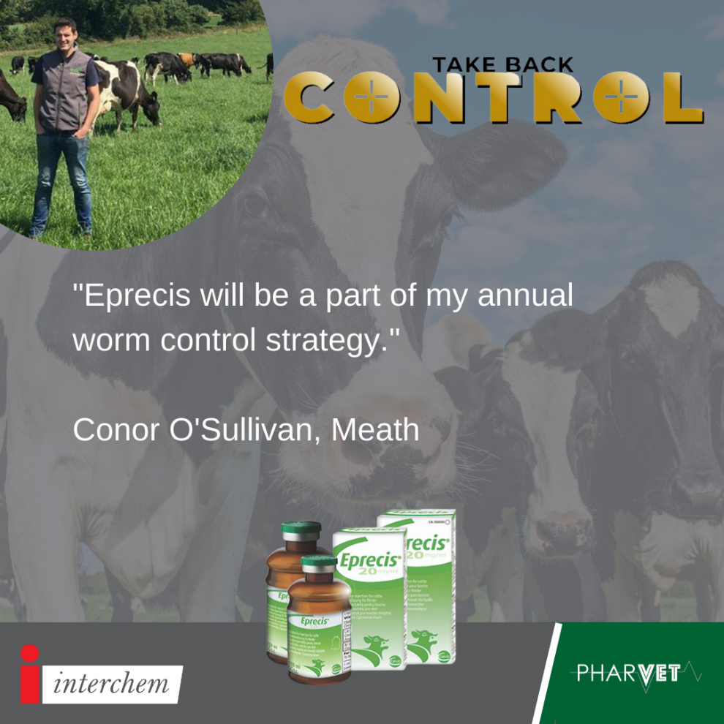

Conor uses Eprecis for a number of reasons. Click the link in our bio to find out more. #Eprecis #TakeBackControl

POST 16

Eprecis injection ensures each animal gets the correct dose and it gets to work quickly. #Eprecis #TakeBackControl

POST 17

Eprecis is the only injectable eprinomectin on the Irish market with ZERO milk withhold. It is effective against major gut parasites and lungworm #TakeBackControl

POST 18

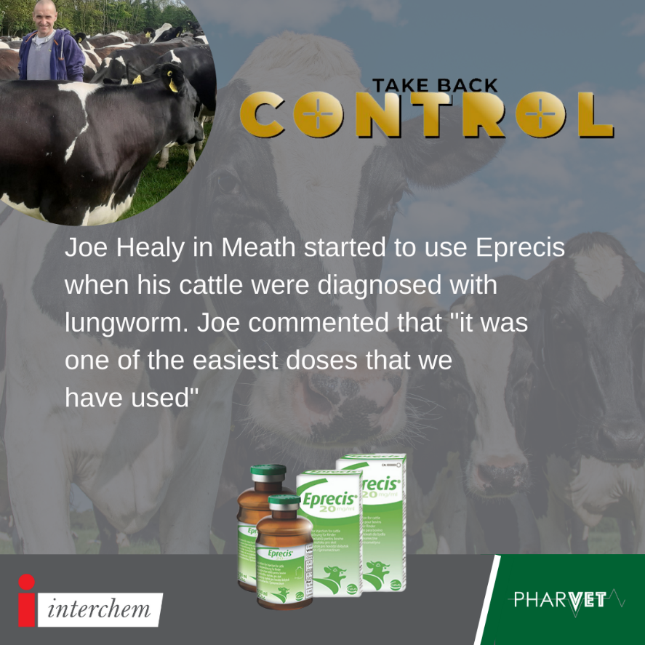

Eprecis injectable is the only injectable eprinomectin on the Irish market and is effective again lungworm. An outbreak of lungworm can cause significant financial loss to a farm, up to €159-€167 per cow, through reduced milk yield, mortality, reduced fertility and diagnostic and treatment costs (Holzhauer et al 2011) Animal health and welfare is a concern as lungworm can cause parasitic pneumonia and death. #Eprecis #TakeBackControl

POST 19

Eprecis is the only injectable eprinomectin on the Irish market with ZERO milk withhold. It is effective against major gut parasites and lungworm #TakeBackControl

POST 20

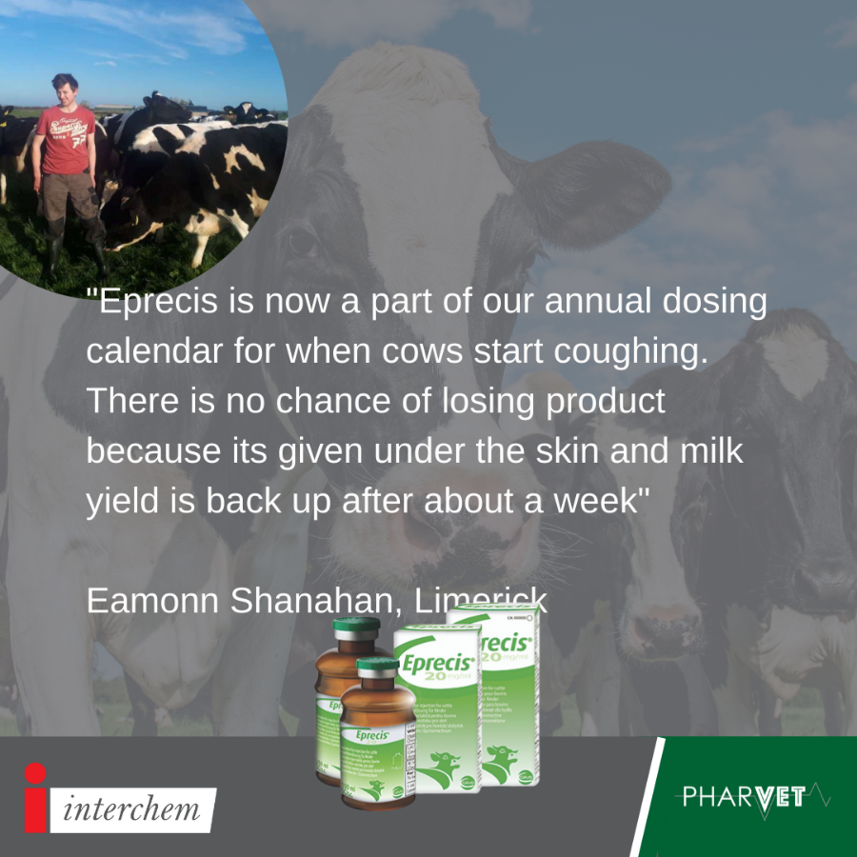

Eamonn graduated from UCD in 2019 having studied Animal and Crop Production. He is now milking 90 cows in Ballagh, Co. Limerick and is using Eprecis to dose his cattle. Eprecis is the only injectable eprinomectin on the Irish market with zero milk withdrawal. Eprecis is affective against lungworm. #TakeBackControl #Eprecis

